Create 2 EC2 instances in 2 different regions and install nginx using the terraform script.

Terraform needs access to your AWS account. You can configure the AWS CLI if it's not done already by running

Command: aws configure

Next, we need to create a project directory

Then, we need to create main.tf file.

This is the main configuration file where we define our resources.

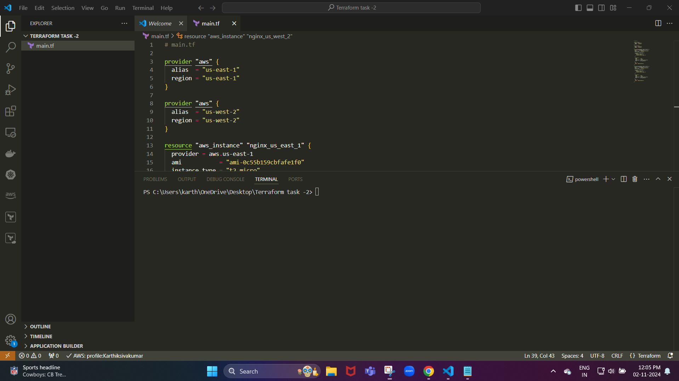

**Providers**: We define two aws providers with different regions (us-east-1 and us-west-2).

**Resources**: We create two EC2 instances, one in each region.

**Provisioners**: The remote-exec provisioner runs commands to update the instance and install Nginx.

**Connection**: We use SSH to connect to the instance and run the provisioning commands. Replace ~/.ssh/id_rsa with the path to your SSH private key.

Now, we need to create variables.tf file

It defines any variables for reusability

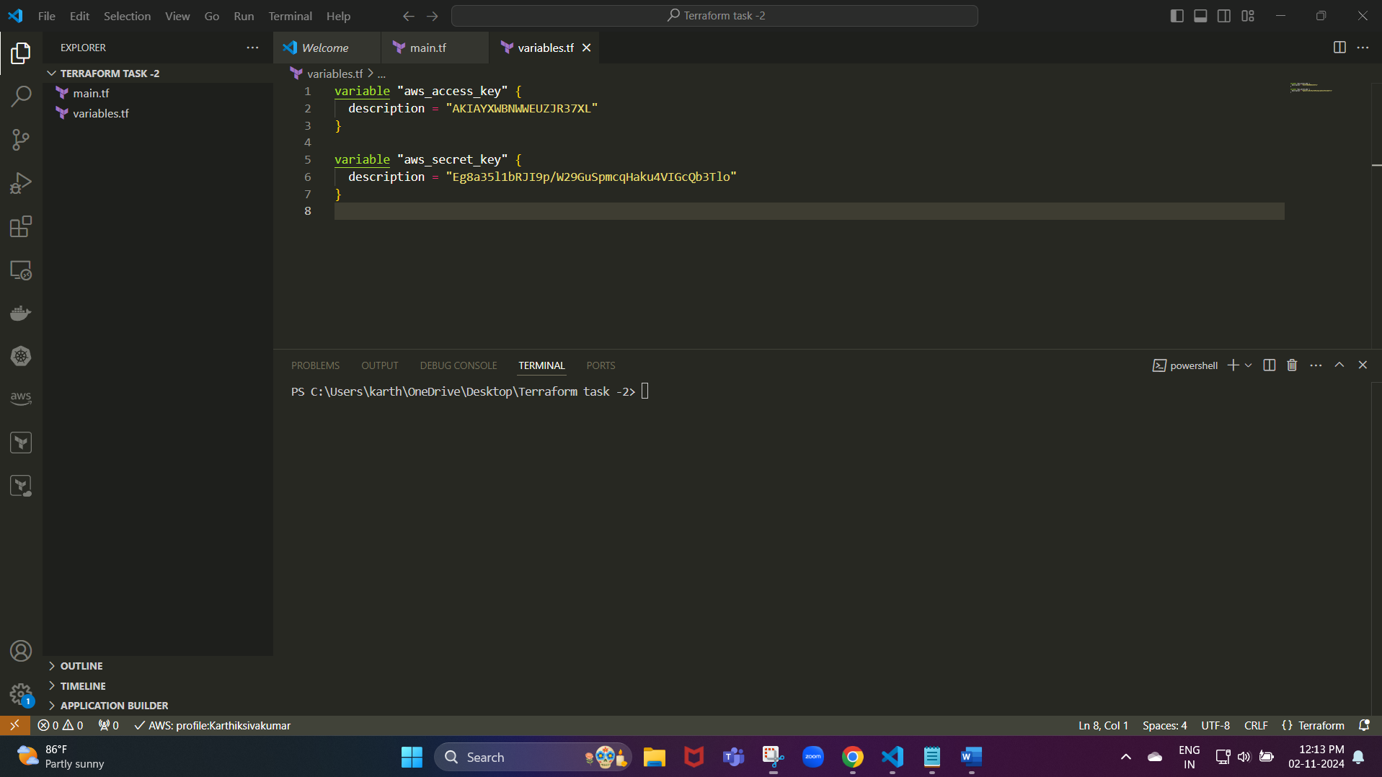

We need to create another file outputs.tf

Output instance information for verification

Now, we need to initialize and apply the terraform

Commands used:

* terraform init
* terraform plan
* terraform apply

